Auto Fill SABR Worksheet Version II

Wednesday, July 19, 2021

# Save the DVH Data

* Open the DVH view in External Beam Planning
* In the "Dose Statistics" Tab Right -Click on the "Show DVH" column
* Select "Show DVH for all Structures"

Fields 
Dose Prescription C] Field Alignments Plan Objectives 
D Optimization Objectives 
Plan 
LUNL 
LUNL 
LUNL 
Dose Statistics 
Course 
View Columns... 
Show DVH for All Structures 
Hide DVH for All Structures 
pproval Status 
pproved 
pproved 
pproved 

* DVH values will be calculated
* Right-Click within the DVH
* Select "Export DVH in Tabular Format…"
* A “Save As” dialogue box will appear.

't 
Organize 
This pc 
Dosimetry Planning Documents SABR Plan Evaluation 
New folder 
Name 
build SA8R_pIan_report 
CD,'DVD Drive (D: on 8URO KC2834) 
temp 
Desktop 
Build SABR Plan Report 
Documents 
example.dvh 
Downloads 
SABR Plan Report 
Local Disk (C: on 8URO KC2834) 
Web Sites on MSN 
Network Drive (I: on 8URO KC2834) 
Network Drive (h. on 8URO KC2834) 
Network Drive (L: on 8URO KC2834) 
Network Drive (M: on 8URO KC2834) 
Network Drive (N: on 8URO KC2834) 
Network Drive (P: on 8URO KC2834) 
File name: example.dvhl 
Save as type: All Files 
Hide Folders 
Date modified 
24,'N/2018 11:59 
13/04/2018Dg:32 
16,'N/2018 10:57 
24/04/2018 12:36 
24/04/2018 DEI 
Search SABR Plan Qaluation 
Type 
File folder 
File folder 
Shortcut 
Text Document 
Microsoft Excel 97... 
Size 
z 604 
Cancel 

* Select the folder:
  + M:\Dosimetry Planning Documents\SABR Plan Evaluation\DVH Files
* Change "Save as type" to "All Files"
* Enter a file name ending with ".dvh"

# Run the Plan Evaluation program,

* Run "PlanEvaluation"

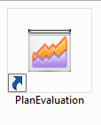

* The main window appears:

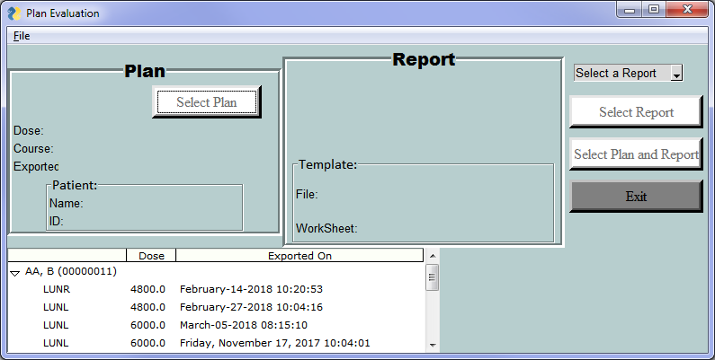

* Select the dvh file from the list in the bottom left of the window.

(This is a list of all dvh files in the directory:

M:\Dosimetry Planning Documents\SABR Plan Evaluation\DVH Files directory)

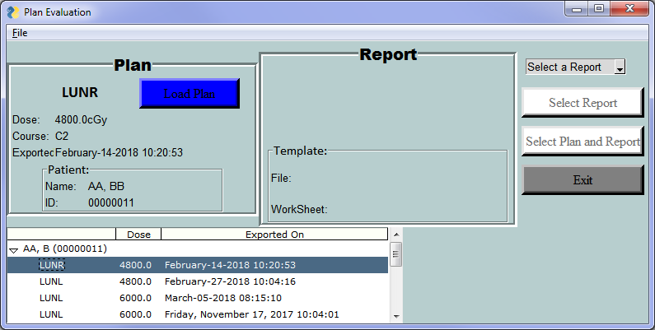

* Click on "Load Plan" to import the dvh file data
* The dvh file will load and the button label will change to “Plan Loaded”.

|  |  |  |
| --- | --- | --- |
|  | **→** |  |

* Select the appropriate Report from the drop-down menu in the top right.

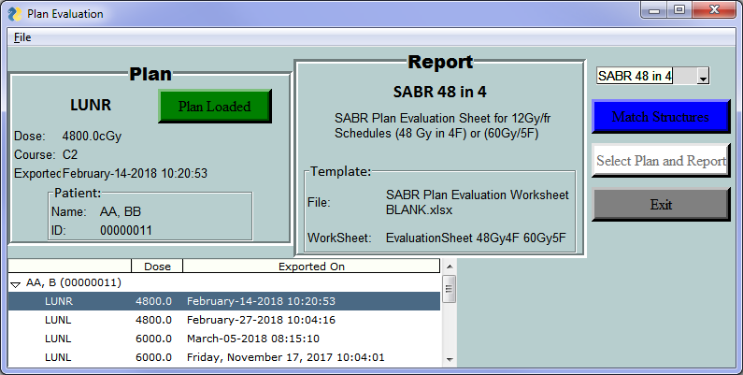

* Click on the “Match Structures” button.
* A new window will pop up allowing you to Match the Plan Report Items with structure names.
* The items are grouped by whether the auto-match was successful or not.

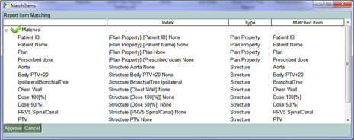

* To manually match a structure to a given report item:
  + Right click on the Click on the desired item and hold the mouse over the Match heading on the menu that appears.
  + Click on the appropriate structure from the list:

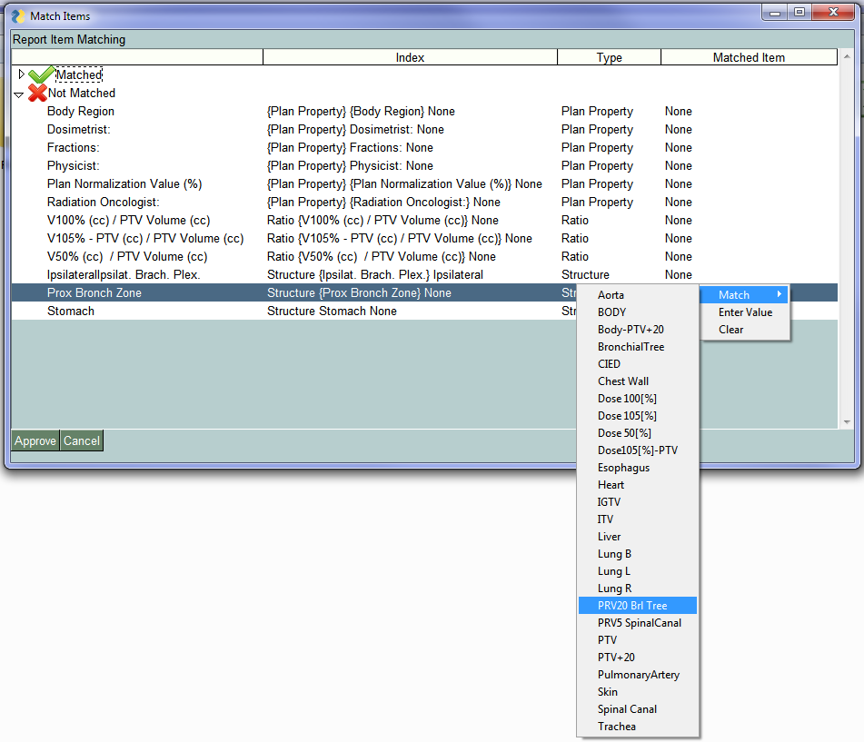

* It is also possible to manually type in text:

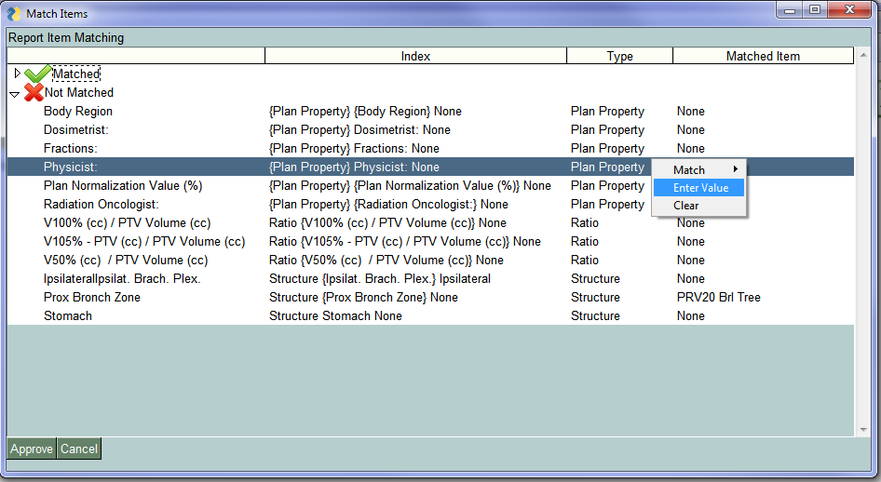Match Structures” button.

* Selecting “Enter Value” from the right-click menu brings up a new window for typing in the text value

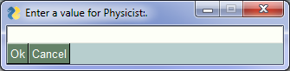

* The value entered will display in the Matched Item column:

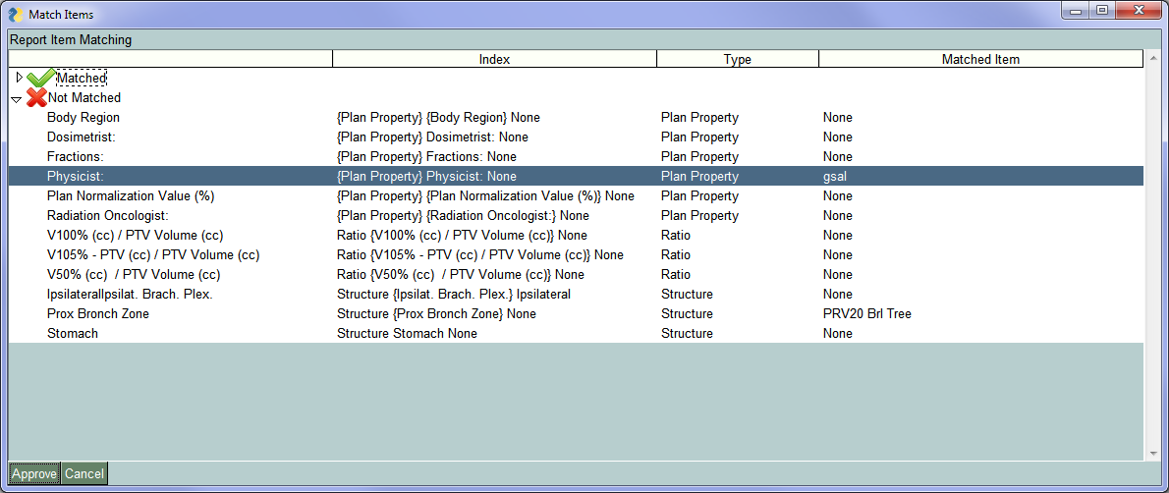

* To remove a match, select “Clear” from the right-click menu”

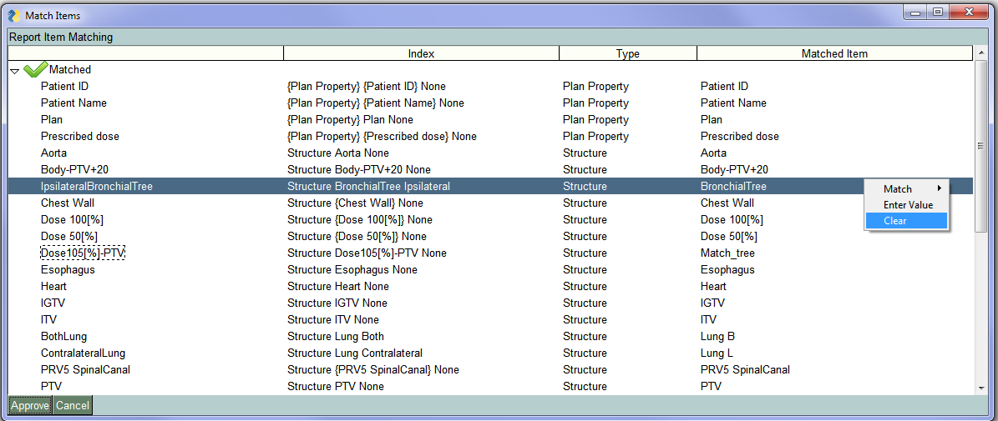

* The value in the Matched Item column will become “None”:

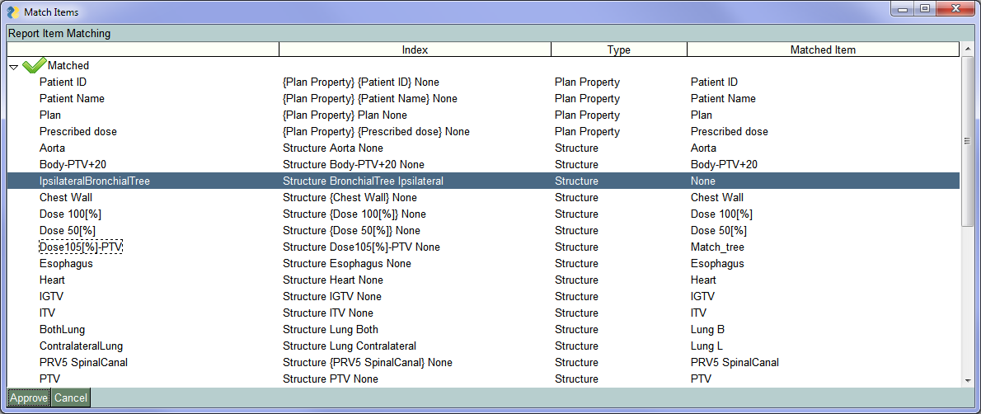

* Once all desired modifications are complete, click on the Approve button in the lower left corner.



* Click on “Generate Report”

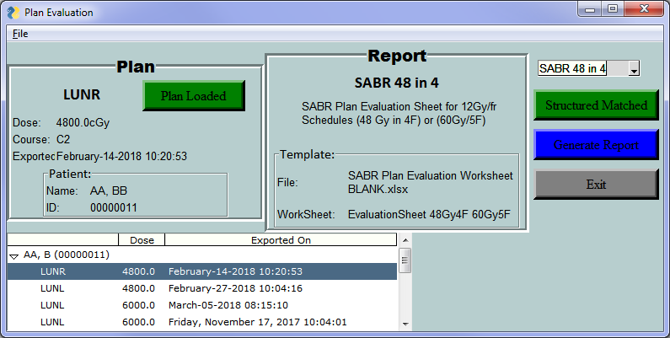

* The SABR Plan Report Form will appear and begin to populate

c 
D 
E 
7 
8 
9 
10 
11 
12 
13 
14 
16 
16 
17 
18 
19 
20 
21 
22 
23 
24 
26 
26 
27 
28 
29 
30 
31 
32 
33 
34 
36 
36 
37 
38 
39 
40 
41 
42 
43 
44 
46 
46 
47 
48 
49 
60 
Volume (cc) 
In" Volume (cc): 
pn.' Volume (cc) 
Total Lun Volume cc 
7 _ 40 
7 _ 40 
24.00 
4413_70 
Normalization: 
00% Dose covers 95% of Tar et Volum 
Ref Dose (96) / 
Calculated Value 
Ref Volume cc 
Plan Normalization Value % 
Dose COM-PTV cG 
PTV Dose Inhom enei 
HIGH 
P TIV- Minimum Dose 
PTV' - VI 
- vgo % 
Dose S illa e: 
Location V105% - P Pv" (cc) — 
V lco•z. (cc) — 
Volume 
LOW Dose S illa e: 
Location 
Volume Vs". g = 
DOSE TO OARs 
Lung Dose 
Mean Dose (contralateral lung 
Mean Dose (Total lun 
(Total Lung) 
Other OARs 
0.00% 
1.063 
4_41 
Calculated Value 
Aorta 
(max point dose) 
V60Gy 10cc V 
Artery-Pulmonary 
(max point dose) 
V60Gy 10cc V 
S Canal 
Ipsilat_ arach_ Plex_ 
(max point dose) 
(max point dose) 
H eart 
Eso 
V30Gy 
(max point dose) 
V60Gy 10cc V 
Chestwall (rib) 
(max point dose) 
(max point dose) 
Trachea 
152 
0.00 
Bronchus 
585_6 
moo 
V60Gy 'occ 
VSOGy= 
Proximal Trachea 
(max point dose) 
94.8% 
moo 
26.60 
61 _6 
105_go 
Maximum Dose (cGy) 
/ Volume cc 
624 
201 _6 
979.2 
1046.4 
1425_6 
1425_6 
5962.0 
4.45 
586_6 
Physicist: 
Protocol 
R uirement 
600/0460/0 
960/0 
64.7% 
4_47 
Tolerance 
(c Gy) / (cc) 
6400 
10 
6400 
10 
3200 
3800 
3 
6400 
10 
4000 
6000 
5 
6400 
4000 
Acceptable 
Yes 
No 
Yes 
Yes 
Yes 
Minor Deviation 
Yes 
Yes 
Yes 
Yes 
Yes 
Yes 
Yes 
Yes 
Yes 
Yes 
Yes 
Yes 
Yes 
& aronch_ Tree: V60Gy S 5cc VOGy 
Stomach and 
(max point dose) 
Intestines V36Gy ICC 
V3BGy= 
Dosimetrist: 
EvalutionSheet 48G F or 60G 
5F 
Evalution Sheet 
8F Calculations 48G 
or 
60G 5F 
Calculations 60G 
RTOG 

# Review Results

* There is a slight difference from that standard form in that values for both Trachea and Bronchus appear, but the maximum of the two goes in the usual spot.

Machine generated alternative text: 43 _________ _________ Chestwall (rib) (max point dose) 59520
44 Trachea Bronchus V5OGyScc V= 4.45
45 19.2 585.6 Proximal Trachea (max point dose) 585.6
46 0.00 0.00 &Bronch.Tree:V6OGy5cc  ??

* Clicking on any of the green buttons, selecting a new dvh file or plan report will move back to that step in the process.

# Note

* This program is a work in progress.
  + Some things will not work as intended
  + Your feedback / bug reports / feature requests are very welcome